Processor PROM's in
PT5300 HD SD Varitime TM Sync Generator

Supplement to: Reference: Manual no.
The processor PROMs in the PT5300 Sync Generators can be installed by technical qualified users.
Exchange of the processor PROMs are typically only required for configuration of some special versions or for update of the software versions.
The version of the master software can be identified during power op of the Sync generator. Immediately after the self-test the display shows “Version: xx.x-yy.y”, where xx.x indicates the master processor software version and the yy.y indicates the internal sync pulse generator software version.

- Open the Sync generator by removing the top cover.
- Identify the master processor PROM on the processor module mounted flat behind the display module. See Picture 1
- By use of suitable IC extractor remove the master processor PROM.
- Insert the new processor PROM. Take care to orientate the PROM correctly.
- Identify the sync processor PROM on the sync module mounted flat behind the display module. See Picture 2
- By use of suitable IC extractor remove the master processor PROM.
- Insert the sync processor PROM. Take care to orientate the PROM correctly.
- Mount the top cover on the Sync pulse generator
- Perform a factory reset: While pressing the two buttons ARROW RIGHT and ARROW LEFT simultaneously turn on the power.
- Observe that the display reflects the changes included with the master processor change.

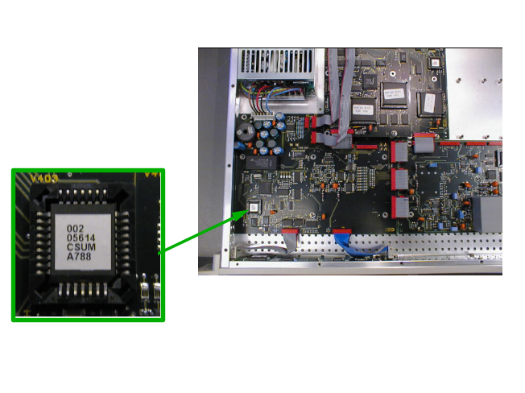
Picture 1: The positioning of the master processor PROM. The lower right corner on the PROM is indicated by a cut in the chip. (Note that code number on actual PROM may differ from Photo)
Part number: 4008 102 08156
Software version: 5.5

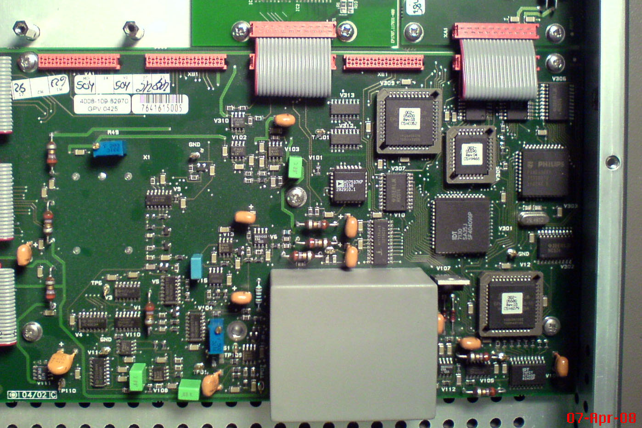
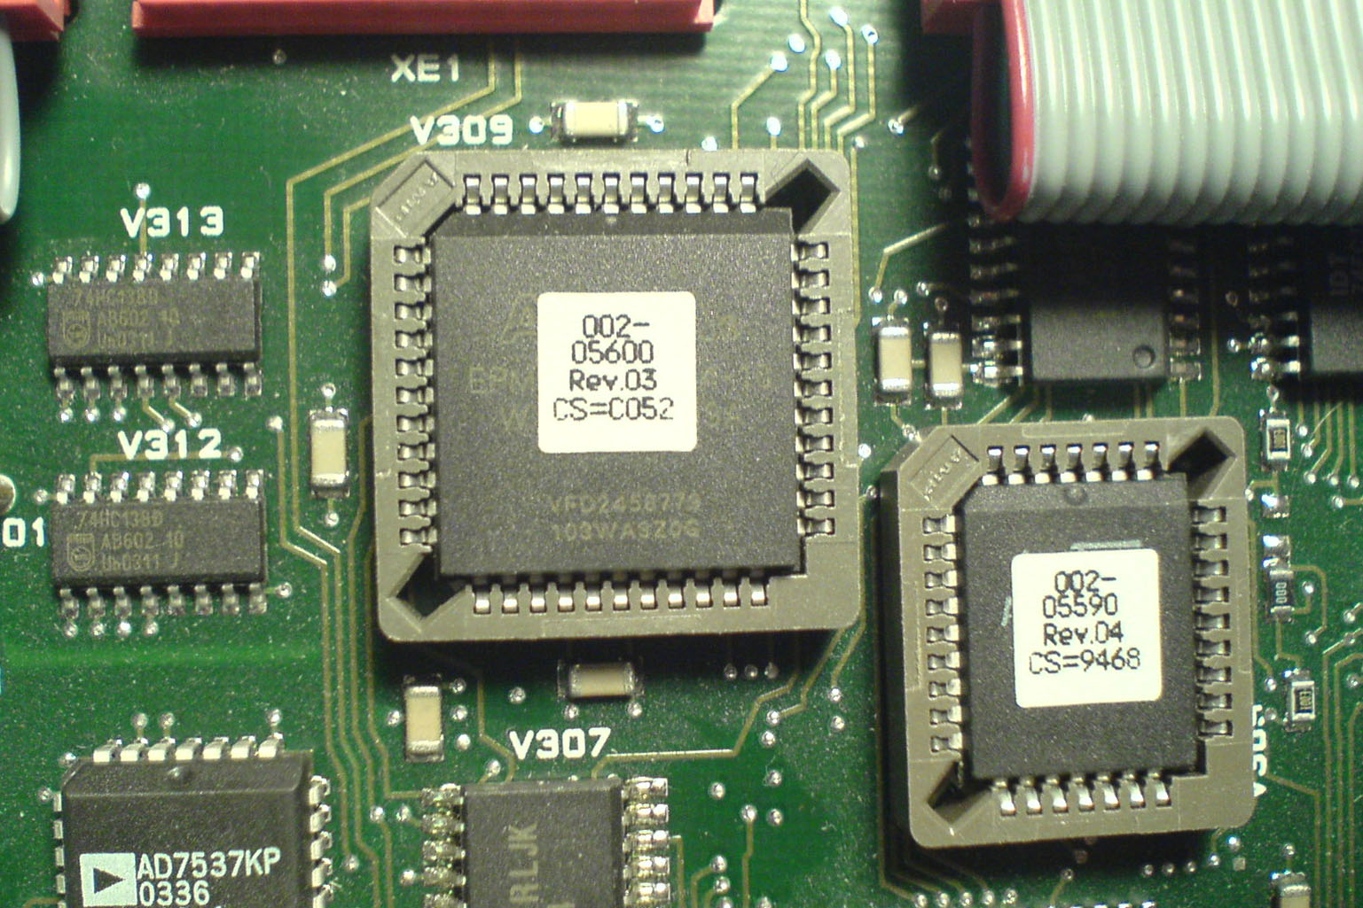

Picture 2: The positioning of the sync processor PROM. The upper left corner on the PROM is indicated by a cut in the chip. (Note that code number on actual PROM may differ from Photo)
Part number: 4008 102 05596
Software version: 3.2

